Section___________________ Date______
Use Parallel Lines and Transversals
Vocabulary | Definition | Picture
POSTULATE 15  CORRESPONDING ANGLES POSTULTAE | If two parallel lines are cut by a transversal, then the corresponding angles are ______________. | 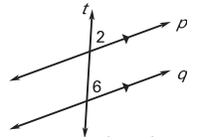
THEOREM 3.1 ALTERNATE INTERIOR ANGLES THEOREM | If two parallel lines are cut by a transversal, then the alternate interior angles are ________________. | 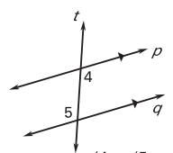
THEOREM 3.2 ALTERNATE EXTERIOR ANGLES THEOREM | If two parallel lines are cut by a transversal, then the alternate exterior angles are ________________. | 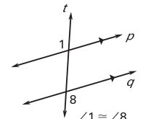
THEOREM 3.3 CONSECUTIVE INTERIOR ANGLES THEOREM | If two parallel lines are cut by a transversal, then the consecutive interior angles are ________________. | 