Section___________________ Date______
Prove Lines are Parallel
Vocabulary | Definition | Picture
POSTULATE 16  CORRESPONDING ANGLES CONVERSE | If two lines are cut by a transversal so the corresponding angles are ______________, then the lines are  _______________. | 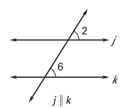
THEOREM 3.4 ALTERNATE INTERIOR ANGLES CONVERSE | If two lines are cut by a transversal so the alternate interior angles are ______________, then the lines are  _______________. | 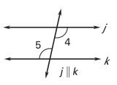
THEOREM 3.5 ALTERNATE EXTERIOR ANGLES CONVERSE | If two lines are cut by a transversal so the alternate exterior angles are ______________, then the lines are  _______________. | 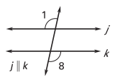
THEOREM 3.6 CONSECUTIVE INTERIOR ANGLES CONVERSE | If two lines are cut by a transversal so the consecutive interior angles are ______________, then the lines are  _______________. | 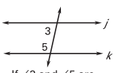
THEOREM 3.7 TRANSITIVE PROPERTY OF PARALLEL LINES | If two lines are parallel to the same line, then they are parallel to each other.

