Section___________________ Date______
Vocabulary | Definition | Picture
SLOPE | The slope of a nonvertical line is the ratio of the vertical change (rise) to horizontal change (run)
SLOPE OF LINES IN THE COORDINATE PLANE
NEGATIVE SLOPE | ___________ from left to right.
POSITIVE SLOPE | ___________ from left to right.
ZERO SLOPE (slope of 0) | _______________ line.
UNDEFINED SLOPE | _______________ line.
POSTULATE 17 SLOPES of PARALLEL LINES | In a coordinate plane, two nonvertical lines are parallel if and only if they have the same ________.  Any two vertical lines are _________. | 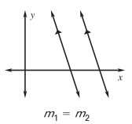
POSTULATE 18 SLOPES of PERPENDICULAR LINES | In a coordinate plane, two nonvertical lines are perpendicular if and only if the product of their slopes is _______.  Horizontal lines are ______________ to vertical lines. | 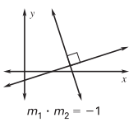
Find and Use Slopes
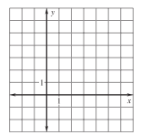
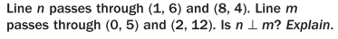
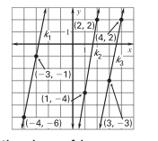
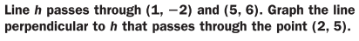
Find the slope of each line.
Which lines are parallel?
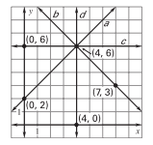
Find the slope of each line.

